Importance of A Firm’s Capital Structure in Times of Financial Stress

I have been investing client money in an ETF that focuses on firms with strong balance sheets for many years. First Trust Capital Structure (FTCS) is a unique ETF that fits nicely in a diversified portfolio constructed for conservative growth. Read on if you are interested in why I believe FTCS is a solid choice in times of financial stress. While this essay is a little technical, I’ll do my best to make it understandable.

What does a strong balance sheet look like? A firm with a strong balance sheet has relatively little debt in its capital structure. For example, Facebook (FB) has a strong balance sheet because only 25 percent of its assets are financed with debt. Ford Motor Company (F), however, has a weak balance sheet because 87 percent of its assets are financed with borrowed funds. For this reason, F is a significantly more risky stock than FB.

Facebook (FB) | Capital Structure
Total Assets | Debt 25%
 | Equity 75%
100% | 100%
Ford (F) | Capital Structure
Total Assets | Debt 87%
 | Equity 13%
100% | 100%

What does a strong balance sheet mean? Facebook has a much lower legal obligation to repay borrowed funds to its creditors than Ford. FB’s management can, therefore, pay out more earning as dividends, if it so desires, or retain those earnings for growth. F’s management, however, is legally obligated to pay its creditors principal and interest for borrowed funds before paying out any dividends. Ford, therefore, has less opportunity for retaining earnings for growth than Facebook.
Why does Ford use so much debt? While debt increases the risk to stockholders, it is a source of cheap capital. Two important reasons make debt cheaper than equity: debt has a priority of claims on the firm’s assets in case of bankruptcy and interest paid on borrowed funds is tax deductible whereas dividends are not. In today’s market, high-quality debt generally costs 2-3 percent while the cost of equity is in the range of 10-12 percent.
What’s the tradeoff? The use of debt increases risk to stockholders but its use is also much more cost efficient than equity. This tradeoff creates a situation where a firm’s management wants to find the optimal amount of debt. Use of some debt is good for stockholders, but using too much debt can be harmful.
Is there an optimal? In the 1950s, Modigliani and Miller (M&M) wrote a seminal paper that identifies the firm’s optimal capital structure. This paper laid the foundation for Modigliani receiving the Nobel Prize in Economics in 1985. The authors concluded that the optimal capital structure is the combination of debt and equity that maximizes the value of the firm to its stockholders.
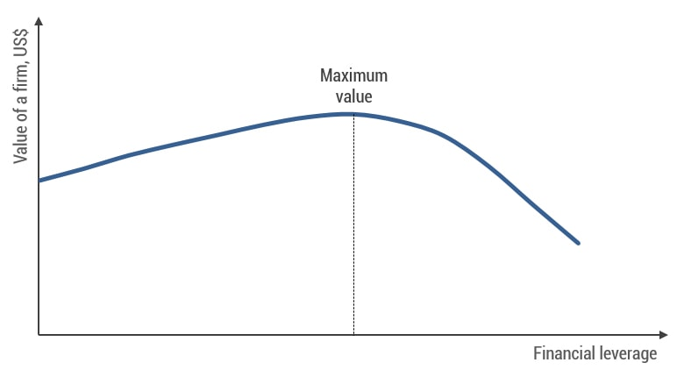
Is capital structure analysis more important now? Capital structure analysis has taken on an increasingly important role recently as a result of the financial stress caused by the virus. Hertz Global, J.C. Penney, and Neiman Marcus are among 28 large firms filling for bankruptcy in May and more are in the making as we speak. In the J.C. Penney case, the firm could not meet its $8 billion debt obligation. Firms with strong balance sheets have the wherewithal to weather the storm of declining revenues and earnings much better than firms that have to repay borrowed funds with interest. It’s all about risk, and investors need to understand the risk associated with debt financing.
How can I find firms with strong balance sheets? Instead of scouring large databases for firms with low amounts of debt in their capital structures, the FTCS ETF employs a methodology that does all the work for you. In addition, FTCS provides excellent diversification within the sector of firms with strong balance sheets.
How do I construct your portfolio? I hope this brief essay helps you understand the reason I may use FTCS in your portfolio. When constructing your particular portfolio, I not only analyze the specific characteristics of each security but also how it interacts with each of the other securities.
I wish to thank Justin Burgess, Ritt Schiano (USN, 06, Retired), and my uncle, Dr. James Powers, for their helpful insights in constructing this essay. Any unclearness belongs entirely to me. As always, I welcome your comments. Best,,,,RC (M: 910-431-6308)

